DESIGNING PROFESSIONAL BUSINESS CARD

1. INTRODUCTION
   1. OVERVIEW

A business card typically includes the giver's name, company or business affiliation (usually with a logo) and contact information such as street addresses, telephone number(s), fax number, e-mail addresses and website.

1.2Purpose

 business card is a highly personal form of marketing, and does exactly what you need it to. Business cards serve the key purpose of marketing your business and getting your key contact information into your client's hands… all in a matter of seconds. Fundamental to the value of the business card, is its portability.

1. PROBLEM DEFINITION &DESIGN THINKINGEMPATHY MAP

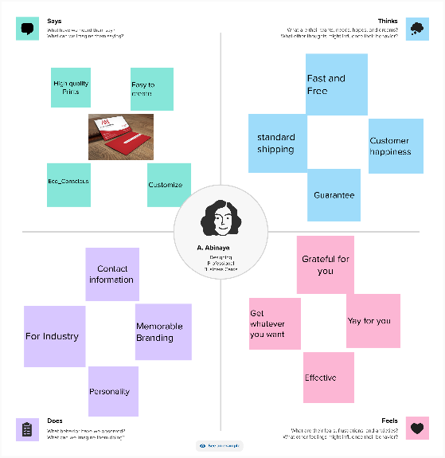

2.2 IDEATION &BRAINSTORMING MAP

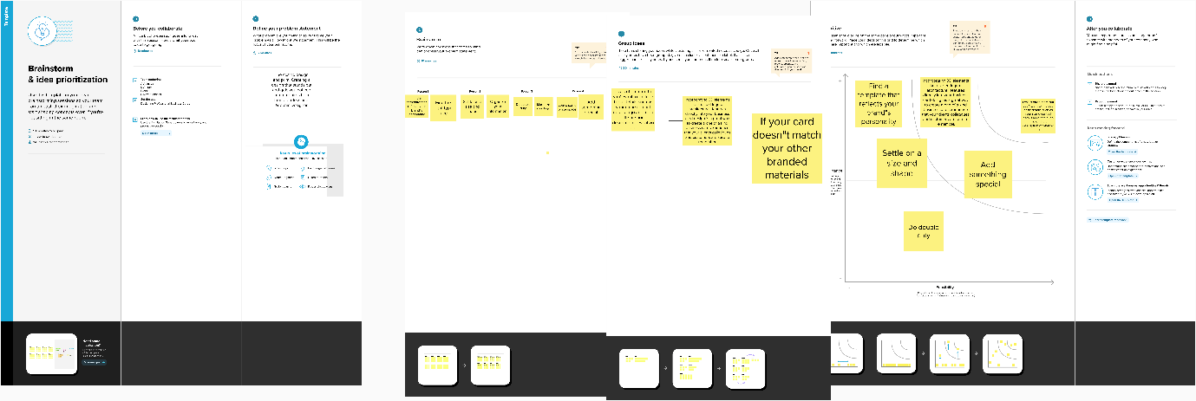

1. RESULT

EMPATHY MAP 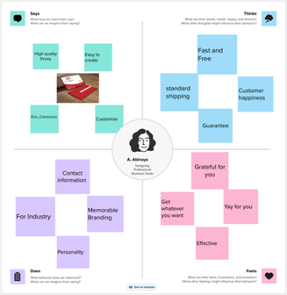

BRAINSTORMING MAP

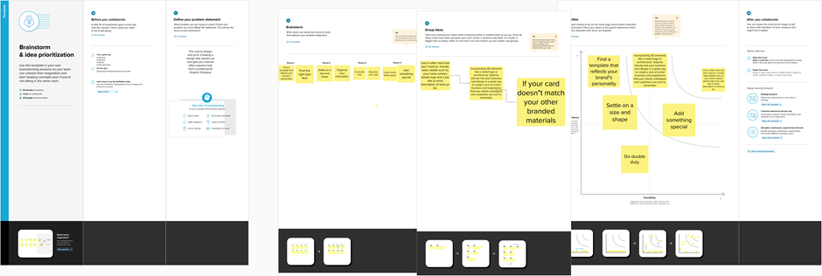

BUSINESS CARD



1. ADVANTAGES & DISADVANTAGES

Affordable Advertisement. ...

Perfect For Events. ...

Tangible. ...

Easy Distribution. ...

People Won't Forget Your Email. ...

Gives A Great First Impression. ...

Small And Convenient. ...

Gives A Visual Aid To Remember Your Business..

The cost to design and print. Creating a design that stands out and gets you noticed often requires help from a professional Graphic Designer. ...

They need to be kept up-to-date. ...

5.APPLICATIONS

Hosting key business information, such as your website, email and phone number, a business card encourages people to contact you, visit your business (online or in real life) and learn more about you. Another way to encourage customers to engage — and hold on to your business

6.CONCLUSION

Having a physical card with your contact information in the local language can go a long way in establishing a business relationship. In conclusion, while digital communication has become the norm in today's business world, business cards remain a Powerful Tool for networking and making a lasting impression.

7.FUTURE SCOPE

The Global NFC Business Card market is anticipated to rise at a considerable rate during the forecast period, between 2023 and 2030. In 2022, the market is growing at a steady rate and with the rising adoption of strategies by key players, the market is expected to rise over the projected horizon.